How to install VS Code and STM32 Extension

This guide explains how to set up Visual Studio Code and the STM32 Extension for Visual Studio Code.

Install Visual Studio Code (VS Code)
- Go to: https://code.visualstudio.com/download
- Download and install VS Code for your operating system (Windows/macOS/Linux).
- When installation is complete, open VS Code.
- Inside VS Code, click on the Extensions Marketplace icon (left sidebar) and install the following extensions:
  - Python (by Microsoft)
  - STM32CubeIDE for Visual Studio Code Extension

Setup STM32 VS Code Extension
The STM32Cube extension requires:

STM32CubeMX

Install these extensions via the VSCode Marketplace.
- Once installed, open the STM32Cube extension settings by navigating to:
  - File > Preferences > Settings or using the gear icon.
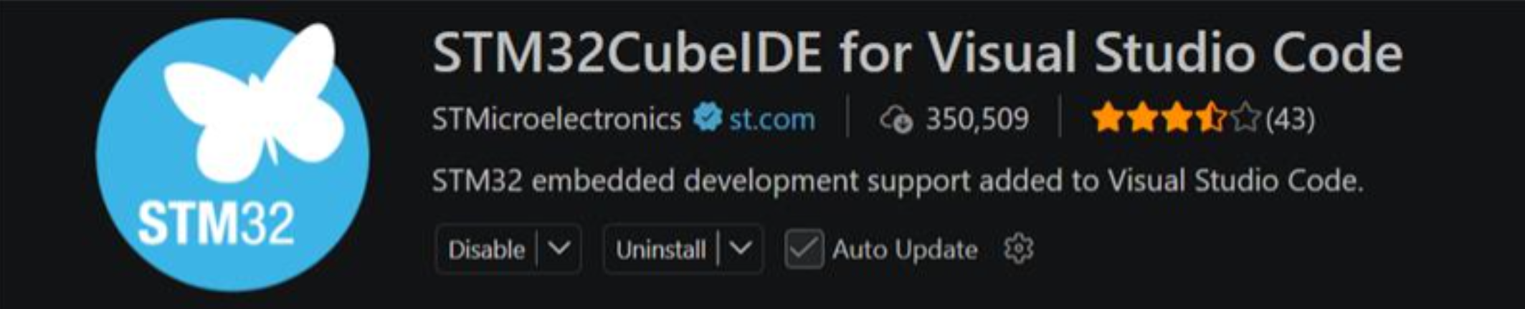

- Set the paths to:
  - STM32CubeMX (e.g. ‘c:\Users\xxx\AppData\Local\Programs\STM32CubeMX\STM32CubeMX.exe`)
  - STM32CubeProgrammer executable (setting this path is optional)
- Open VSCode and select File > Open Folder.
- Navigate to the project folder generated by STM32CubeMX.
- Once opened, go to the STM32Cube extension and import the folder with the project.
- You are now ready to work on your project.

